Healer_Tools Year2 Week3,12 March 2018

* List what to include: artwork , personal information, social media, links, etc

Include my website，I will add many things.

1. **personal information**：name is healer，20 years old，weibo（like ins in other country.），from Zhejiang hangzhou。I like painting very much，and I like travel too，so I want to travel all around the world

<https://weibo.com/5301062336/profile?rightmod=1&wvr=6&mod=personinfo>

**2.artwork**：may I will collect the images which did by who I was interestd, and I prefer Landscape painting，because I like travel a lot ，for example

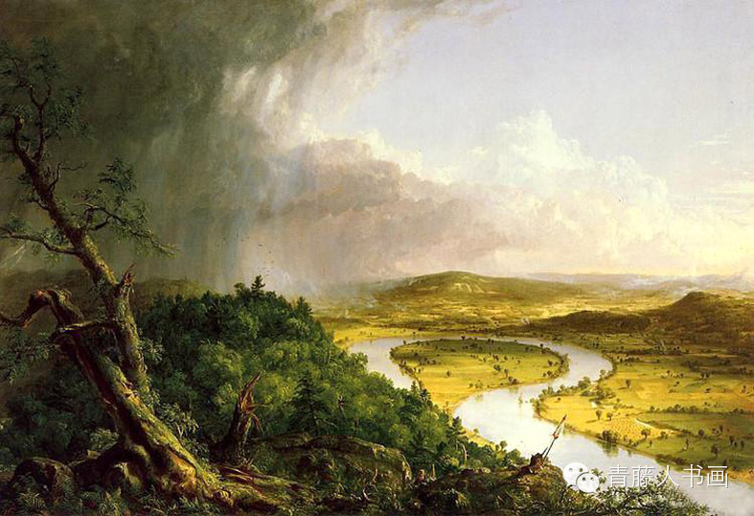

Oxbow lake cole USA 1836.

Canvas oil painting 130.8 x 193 cm.

The metropolitan museum of art, Mrs. Russell sedge donated in 1908.

The painting also has a long name: "after the storm, northampton, Massachusetts." The right side of the painting is a poetic rural scene, with a u-shaped river, reminiscent of the yoke -- a symbol of human control of nature. The left side of the painting is still a thunderstorm. The painting itself reflects cole's ambivalence: he appreciates both human development and natural destruction.

（牛轭湖 科尔 美国 1836年

帆布油画 130.8×193公分

大都会美术馆，罗素·赛吉夫人1908年捐赠

这画还有一个长的名字：《暴风雨后马萨诸塞州北安普敦圣轭山风景》。画的右侧是一幅充满诗意的乡村景象，河流成U形，让人想起牛轭——人类控制自然的象征。画的左侧仍是雷雨肆虐的山野。画的本身体现了科尔的矛盾心理：既欣赏人类开发自然，又担心自然遭到破坏。）

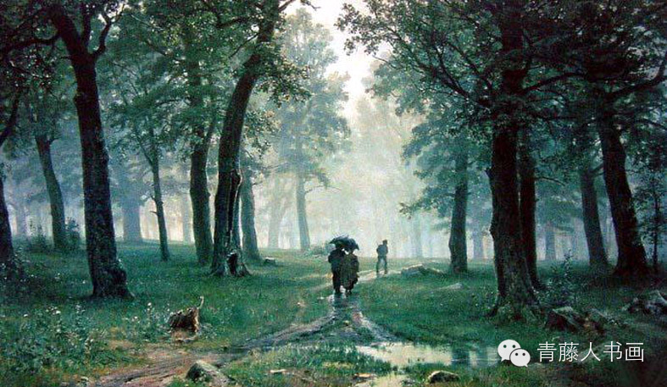

The rain in the forest, Russia.

The oil painting on the canvas is the collection of the art.

It is one of the most beautiful landscapes in the famous painting, and it is a masterpiece of painting the world famous paintings. Painter depicts the light rain in the forest of oak, underground wang with mud, the mud and reflection, haze of signs of approaching rain is in the air, is like concealed, make the vision appears fuzzy, emptiness, far light, elegant, increased dimensional feeling, make a picture fully. The muddy road zigzagged into the distance, and friend savitsky, as usual, added a few people to the picture, a couple holding an umbrella, and a hunter with a gun in front of him.

（林中雨滴 希施金 俄国

布面油画 莫斯科特列恰科夫美术馆藏

这是名画中最美的一幅风景画，作为正一艺术推出世界名画欣赏500幅的压轴之作。画家描绘了橡木林中微雨的情景，地下汪着泥泞，泥水中还有倒影，空气中飘着蒙蒙的雨意，若隐若现，令远景显得模糊、空蒙、远淡、飘逸，增加了空间感，使画面一下通透起来。那条泥路弯弯曲曲通向远方，朋友萨维茨基照例又在画面上给添加了几个人，一对夫妻打着伞，前面还有一位猎人扛着枪。）

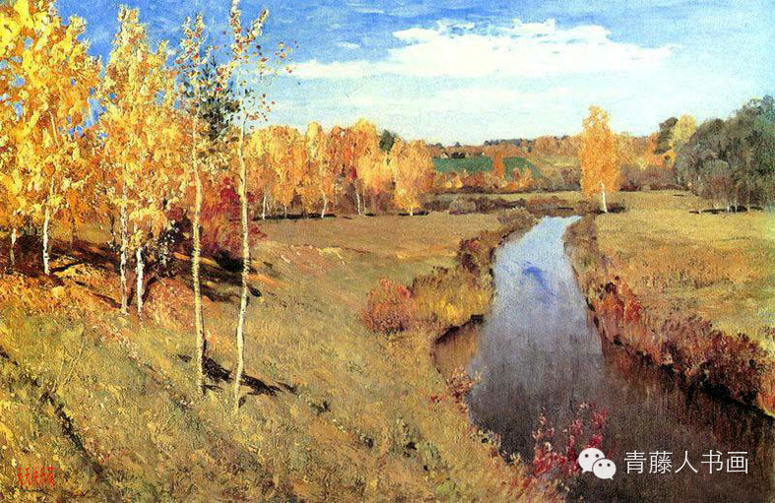

Golden autumn in Russia 1895.

Oil painting Moscow museum of fine arts.

In the mid-1890s, levitan drew some lyrical works, notably the golden autumn. The painter USES the natural and robust strokes and color blocks, and describes the natural scene of golden autumn in Russia. This painting is an ode to autumn. A clear blue sky, as if a living breathing, like floating in the sky gray clouds, the sun shine through the clouds on the same bright blue stream, fields are change from green to yellow, the leaves have all become golden brown.

（金色的秋天 列维坦　俄国 1895年

油画 莫斯科特列恰科夫美术博物馆

列维坦在19世纪90年代中期画了一些抒情性作品，杰出的有这幅《金色的秋天》。画家运用潇洒稳健的笔触和色块，高度概括地描绘了俄罗斯金黄色秋天的自然景象。这幅画是一首秋天的颂歌。湛蓝的天空，仿佛活生生的会呼吸似地，天空飘浮着灰白色的云，阳光穿过云朵照耀在同样蓝得发亮的小溪上，田野正在由绿变黄，树叶已全部变成金黄色。）

**3.some of my works**，not only homework and projects，and also something I did by myself，and interesting things. maybe some pictures I have drew. Now I don’t have photos.

4.some photos took by myself，somewhere I had been there，which remained me great memories，such as Japan、Vietnam、yunnan and so on.

And follow this is the example picture.

